

Consulting Report:

INSAID TELECOM

Group No. 1010

Date of Submission: July 24th

Table of Contents

1. Introduction 3

2. Project Description 3

3. Problem Analysis 3

4. Sources of Data (Explain about database connection, tables and their columns) 4

5. Challenges with the data 4

6. Data Analysis 5

a. Which age group forms the biggest consumer set for Insaid? 7

b. Is there any difference in customer age segments in the two biggest states? 8

c. What are the preferred call timings for the younger generation? 9

d. Is the any preferred phone brand for Female consumers ? 10

e. Is there any preferred brand across states or age groups 11

7. Analysis Summary 12

8. Proposed Solution for Customers 13

9. Conclusion 14

# Introduction

Insaid Telecom, one of the leading telecom players in India is in fiercely competitive market. As such it needs to tailor its offerings to better attract and retain customers.

# Project Description

With a subscriber base of 1,206.22 million, as of March 2018, India accounted for the 2nd largest telecom network in the world. It is also one of the most competitive markets with low ARPUs and one of the lowest data charges in the world. Availability of affordable smartphones and lower rates are expected to drive growth in the Indian telecom industry.

In addition, the 1 billion+ population (the majority of which was hitherto disconnected from the online sphere) represents a monumental untapped market for the telecom sector. By 2025, the country is projected to have  [850 million new online users](https://www.consultancy.in/news/85/india-to-have-850-million-online-users-by-2025-finds-bcg), according to management consultancy [BCG](https://www.consultancy.in/firms/boston-consulting-group).

Hence it is of the utmost importance for companies to tailor their offering to clients’ requirements and to differentiate themselves from the competition in order to gain the maximum marketshare.

# Problem Analysis

Insaid Telecom wishes to leverage and utilise the data available to it to provide a better offering to the customers.

It has data pertaining to 9363 (unique device Ids) across 6 states () in India, including their age, gender, and the phone brands they prefer to use. It also has some behavioural data on these users including the frequency and timing of their voice usage.

In addition to finding out salient features of this dataset, the client has entrusted us to provide an answer to the following key questions in order to come up with key insights to increase its marketshare:

a. Which age group forms the biggest customer segment for INSAID Telecom?

b. Is there any difference in customer age segments in the two biggest states?

c. What are the preferred call timings for the younger generation?

d. Is the any preferred phone brand for Female consumers ?

e. Is there any preferred brand across states?

f. Are there any differences in usage between metro and non-metro consumers?

# Sources of Data (Explain about database connection, tables and their columns)

The client provided the data in three separate sets. There was csv file with event specific data ( each activity performed by a Device) and two SQL databases. The Events file had details of the voice calls made by each device along with the latitude, longitude, city of origin and the corresponding state.

The SQL files had data on the gender, age and brands associated with each device ID. These files were then assimilated.

# Challenges with the data

1. The data sets needed to be combined. This was done using the device IDs which were a common field in all three data sets.
2. The states data was missing for some events. To fill the missing values the state value of the city was found using mode of state of the particular city.
3. The latitude – longitude data was missing for some of the events. To fill the missing values, mode of the cities latitude longitude data was used
4. The latitude longitude – longitude data was wrong for some cities. This was corrected using latitude and longitude city value .
5. Phone brands and models were not in English
6. 453 device_ids (approx. 01%) were missing in the dataset which was updated using mode of longitude and latitude available for these data.

7 States concentrated on for analysis amounts to 534462 data points

# Data Analysis

In this data analysis, we have tried answering some of the key client queries, in addition to the basic analysis done on the data. Some of the preliminary analysis is as follows:

#todo

6.1 Distribution of users across the 4 important variants are depicted in the following graphs

**Gender**: Male dominations is more by 25%

**Age Segment**: Age Segments 25-30, 20-25 and 30-40 age range dominate the market

**States**: Tamilnadu has the highest market share followed by Uttar Pradesh

**Phone Brands**: Samsung, Xiomi and Huawei have highest market share

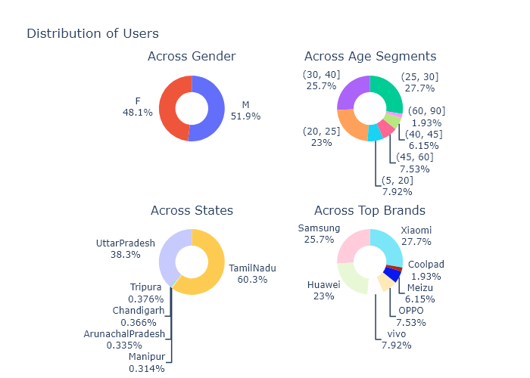

6.1 Distribution of Phone brands across 3 variants

**Gender , State, Age Segment:** Xiomi, Samsung and Huawei top the market irrespective of gender or age. There are few brands coolpad, Leco are doing well in states like Tripura though the market share is less .

Tamilnadu and UttarPradesh have higher market share compared to other 4 states (Manipur,Chandigarh,ArunachalPradesh and Tripura). Hence the graphs have been plotted in 2 different groups.

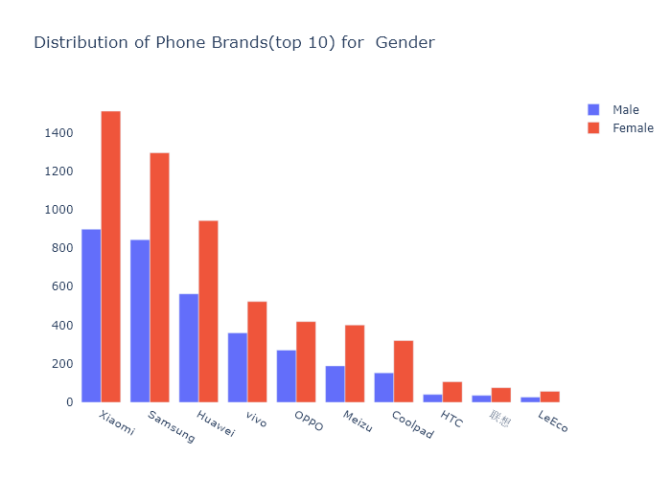

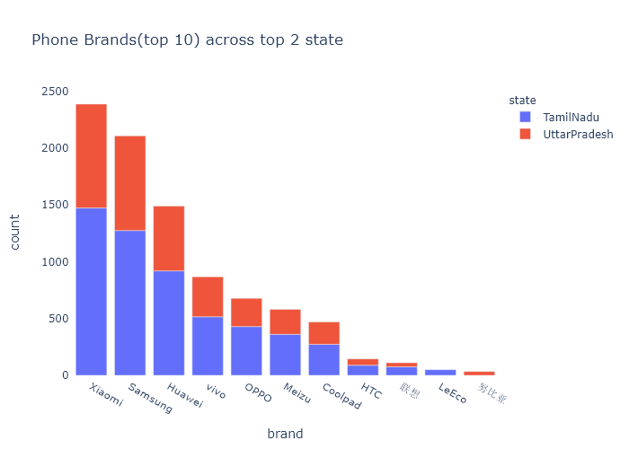

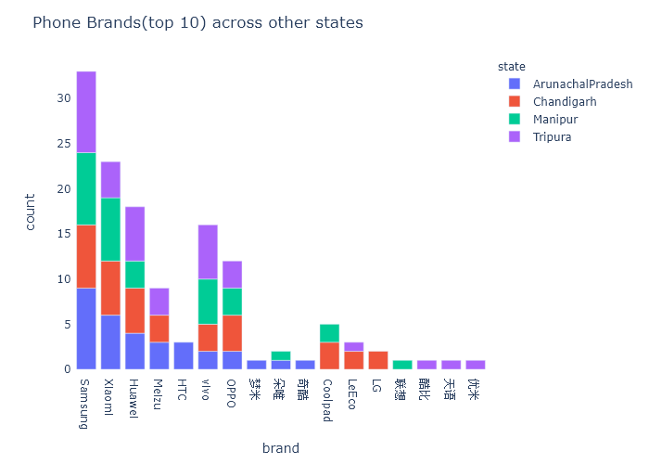

## Is there any preferred brand across states or age groups

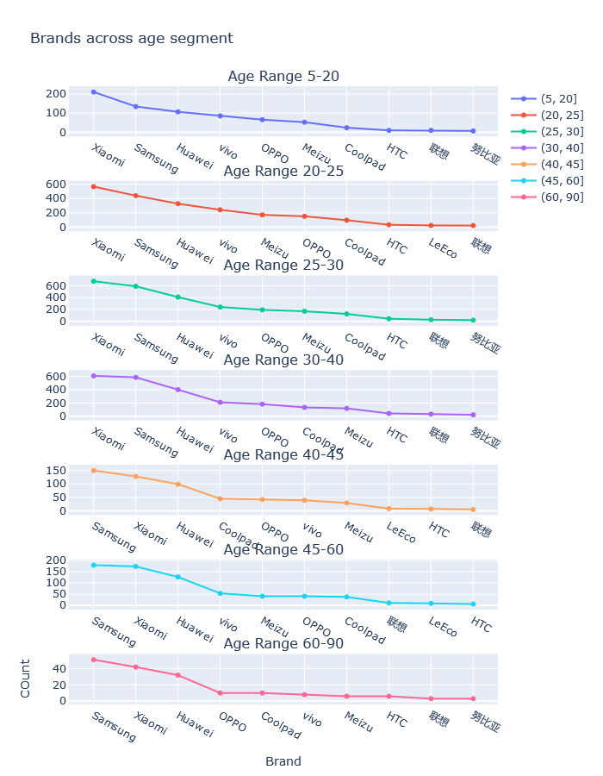

As we can see from this chart, the top 5 phone brand choices remain the same across age groups.

Gender distribution across states

1. Tamilnadu and Uttar Pradesh

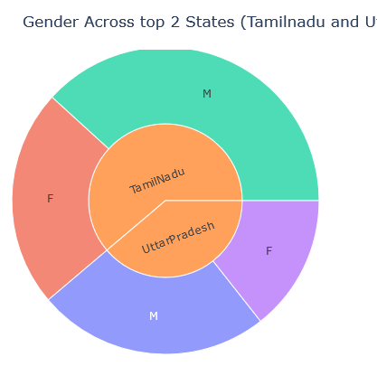

b) Manipur, Arunachal Pradesh, Chandigarh and Tripura

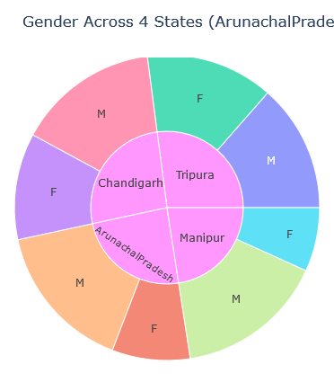

Brand preference across gender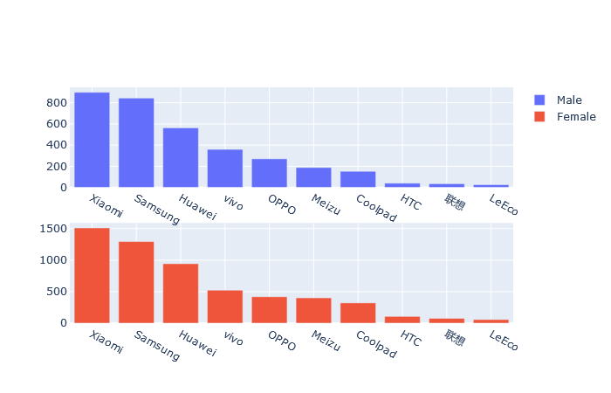

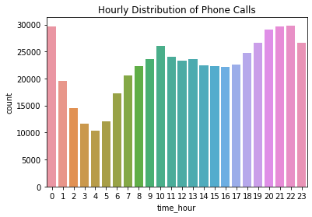

## Which age group forms the biggest consumer set for Insaid?

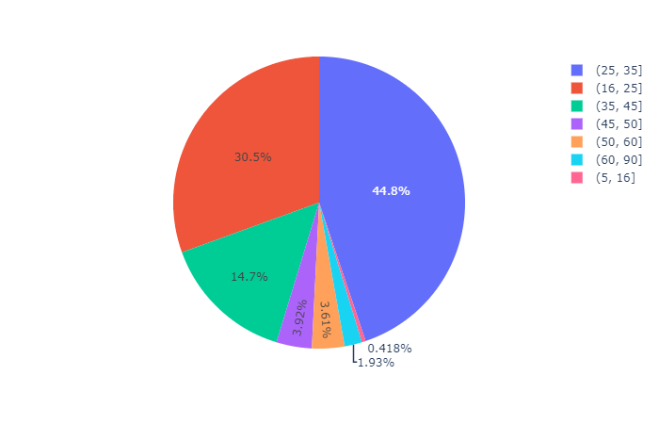

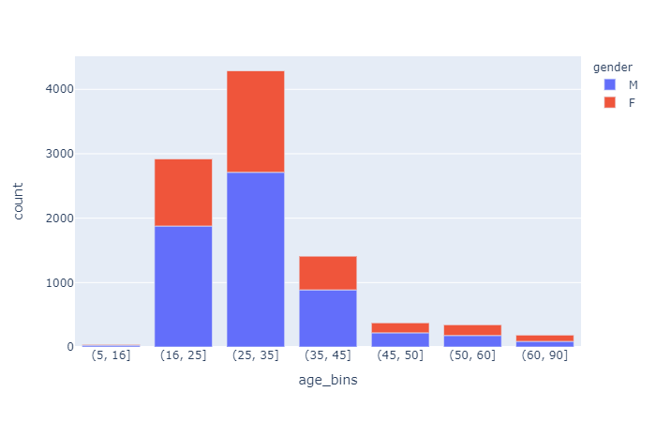

As we can see from the graph, INSAID has the maximum number of customers in the 25-35 age group followed by the 16-25 segment. These two segments together account for 75% of their clients.

Further within these segments there is a much higher percentage of men than women as we can see from the second graph.

-

## Is there any difference in customer age segments in the two biggest states?

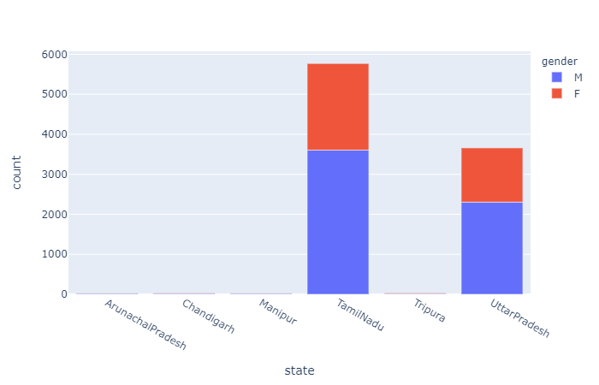

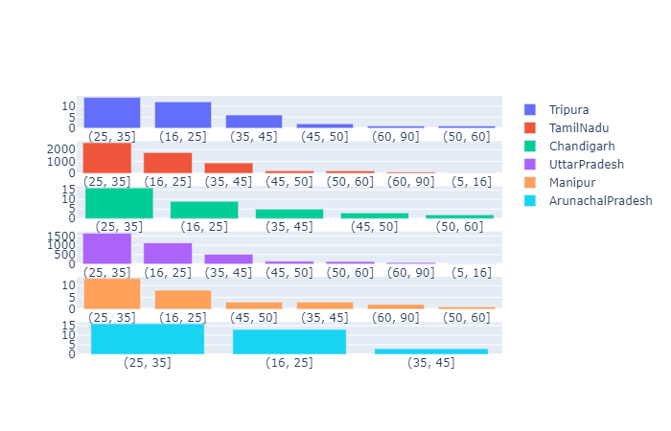

As we can see from the chart above Tamil Nadu and Uttar Pradesh form the two largest states in terms of customer distribution. In both these states the customer segments that are the majority are the 25-35 followed by the 20-25 group.

## What are the preferred call timings for the younger generation?

## Is the any preferred phone brand for Female consumers ?

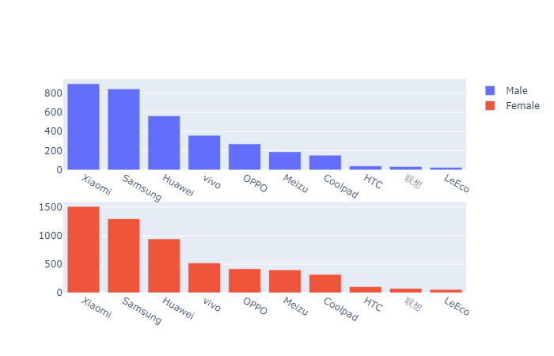

As we can see from the data the five most popular phone brand remain the same, irrespective of gender

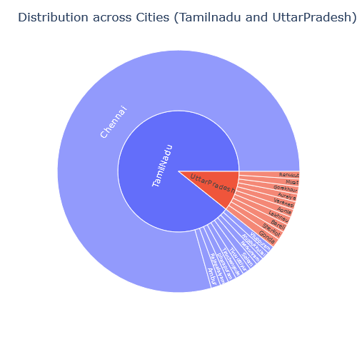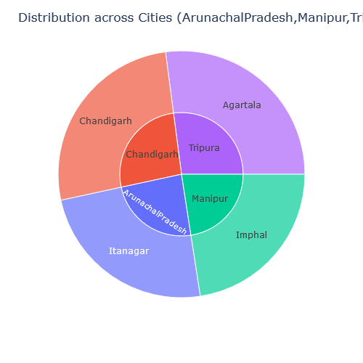

Overview of Users across states

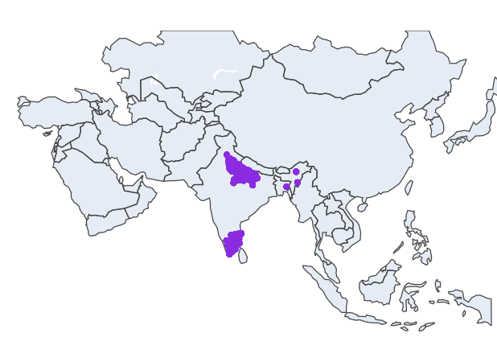

# **Analysis Summary**

**Gender**: Male dominations is more by 25%

**Age Segment**: Age Segments 25-30, 20-25 and 30-40 age range dominate the market which amounts to 65% of the market share

**Phone Brands**: Samsung, Xiomi and Huawei have highest market share

There are few brands coolpad, Leco that are doing well in states like Tripura though the market share is less

**States**: Tamilnadu has the highest market share followed by Uttar Pradesh

**City**: Chennai has the largest number of users.

States other than Tamilnadu and Arunachal Pradesh have reach in only 1 city

Other cities have to be targeted or the operations can be dropped from these states as a cost saving measure and marketing activity can be taken up in UP and Tamilnadu for tier2 cities.

# **Proposed recommendations for Insaid Telecom**

1. Hourly call pattern, Daily call pattern
   1. This can be further divided to particular state and gender
   2. Free Talk time at particular hours (2a.m – 5a.m) can be given and discounts based on genders for the periods where there are less usage, to increase the usage.
2. Phone Brand Usage
   1. We can analyse the brand usage across states and genders
   2. The offers can be given by various brands in relevant states and for genders where there are less usage
3. Distribution across state
   1. There is a lot of untapped potential in various tier 2 states. The reach of mobile is very less in these areas. Marketing activities in the states of Manipur, Tripura, Arunachal Pradesh and Chandigarh has to be carried out
   2. We need competitor data for reach of telecom providers in these areas and call needs to be taken
   3. Even in state like UP there is a lot of scope to reach tier 2 cities
   4. In Tamilnadu other than Chennai though the reach is more, subscribers are less
   5. States other than Tamilnadu and Uttar Pradesh have the reach in only 1 city
   6. Other cities have to be targeted or the operations can be dropped from these states and save cost.
   7. Marketing activity can be taken up in UP and Tamilnadu for tier2 cities.
4. Age Segment
   1. Consumers are more in the age bracket 20 to 35. This age group has to be targeted in the tier2 states through outreach programs tying up with corporates and college students can be targeted by giving discount or devices at lower prices

# Conclusion

There a lot of untapped potential across the geography of India. Marketing activities should be tailored according to the need across different states and launch of the network can be done in the various areas which remains untouched as there is lot of scope available.